# Learning Sequence

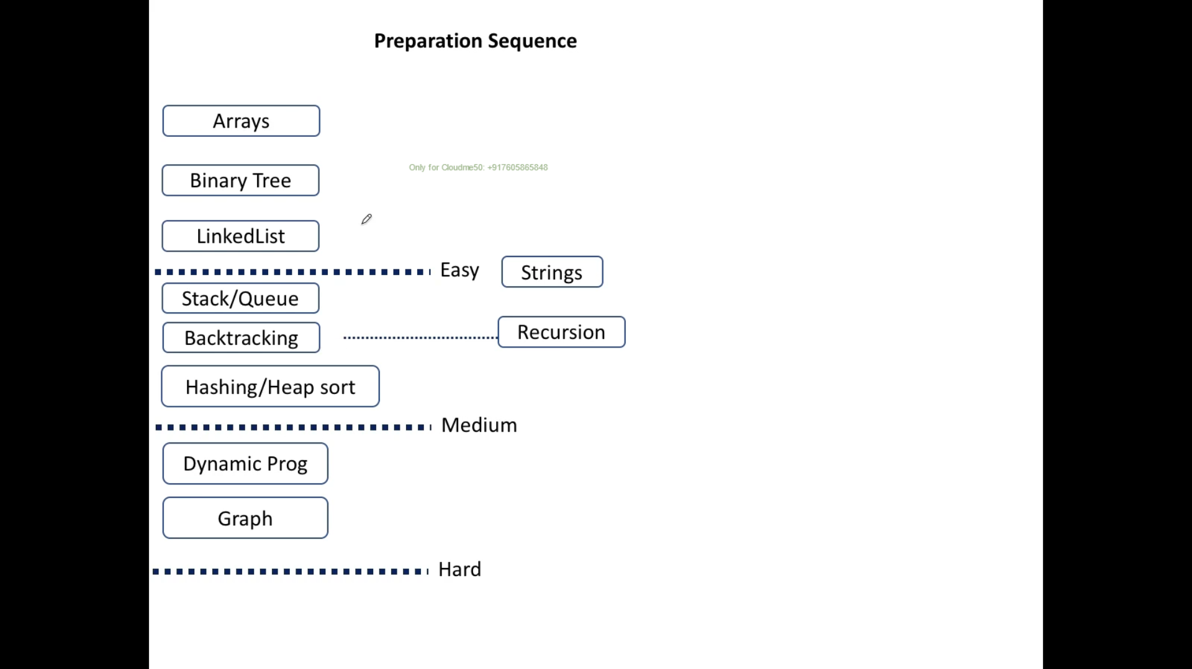

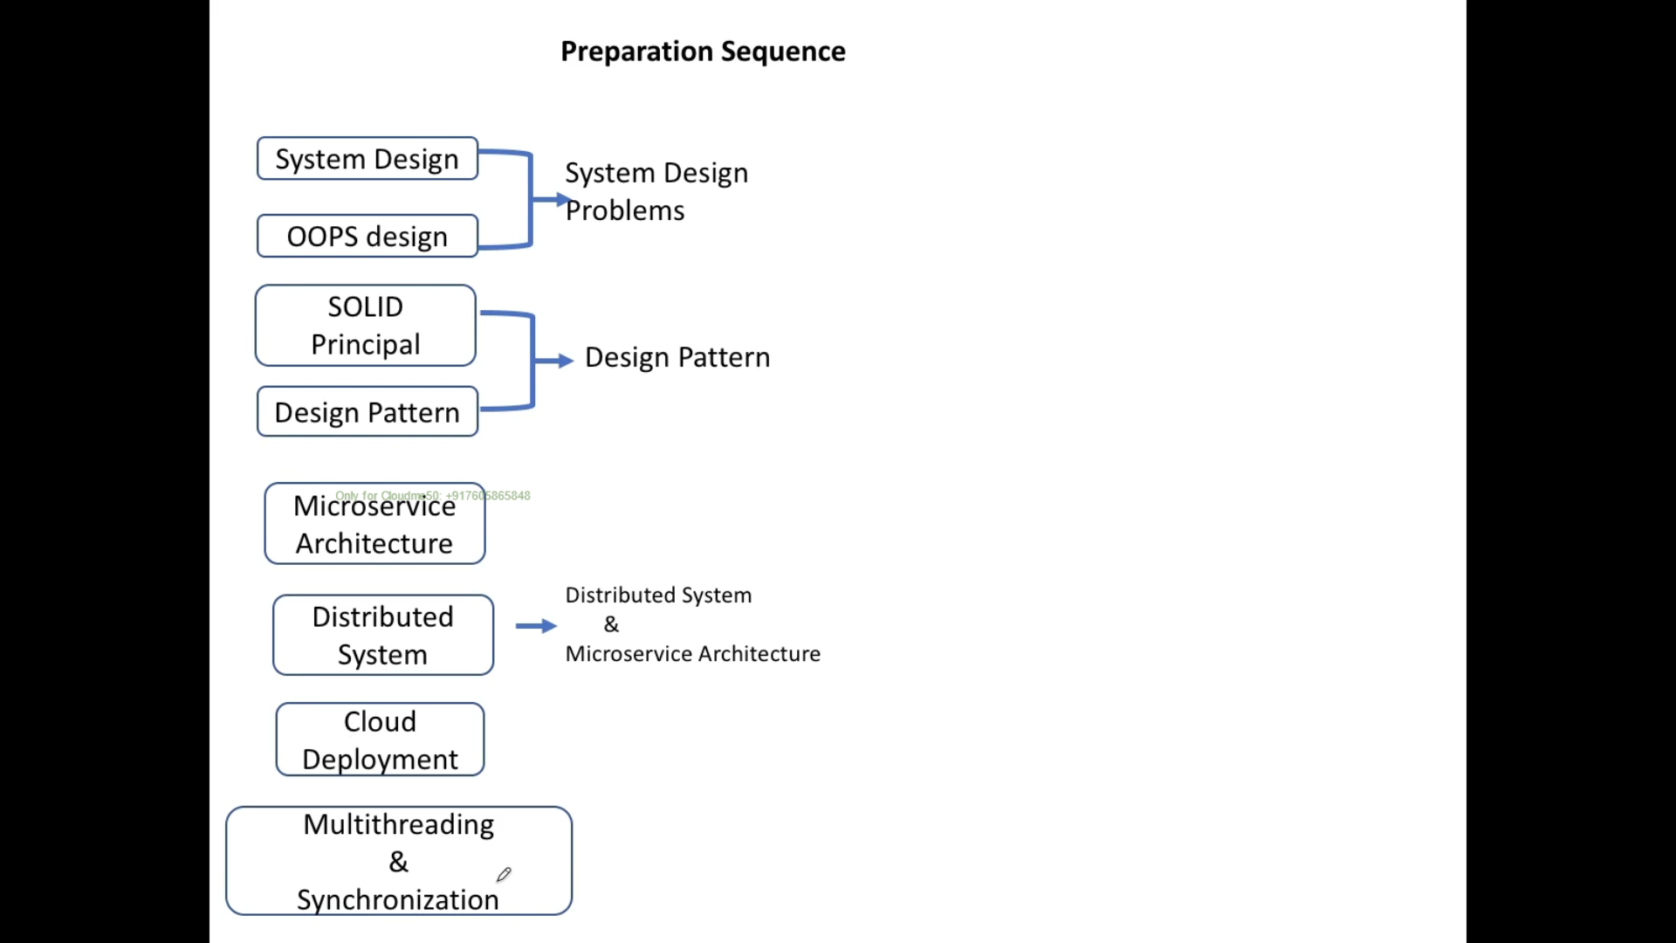

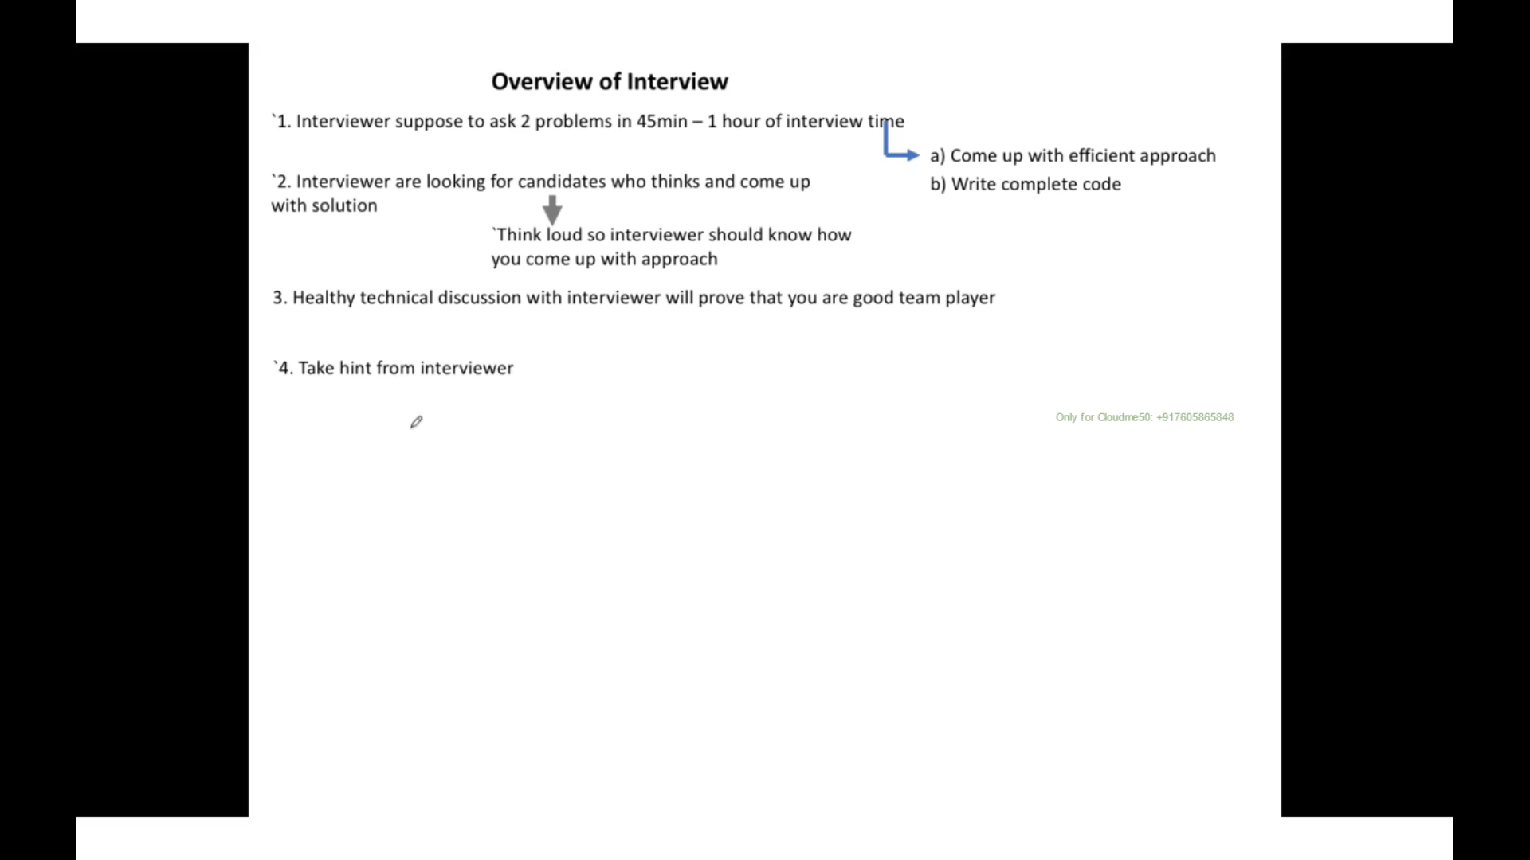

# **Space and Time Complexity of Algorithms by Using Big O Notation**

## **Time Complexity**

* + - One for loop – O(n)
    - Two nested for loop – O(n2)
    - Three nested for loop – O(n3)

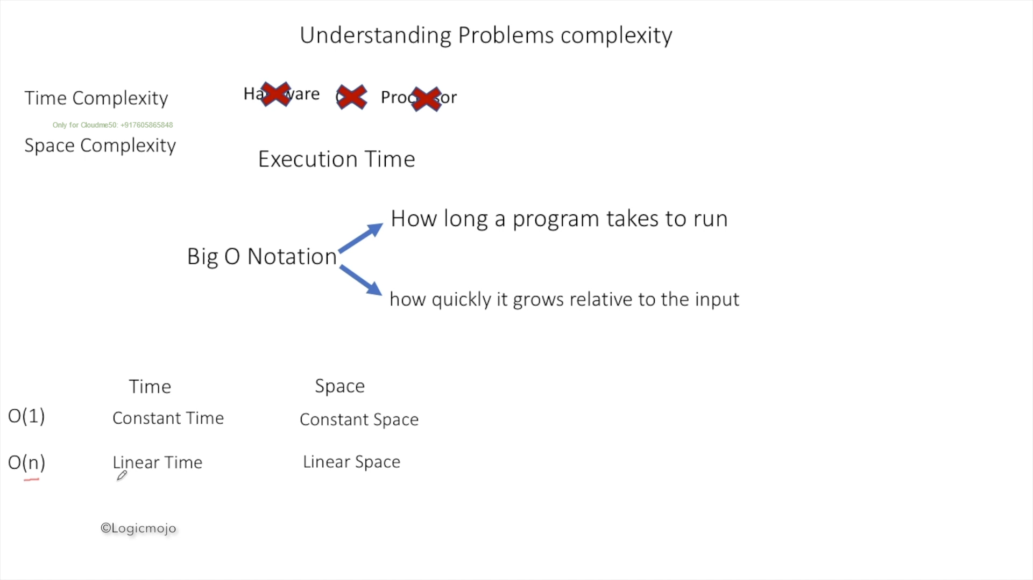

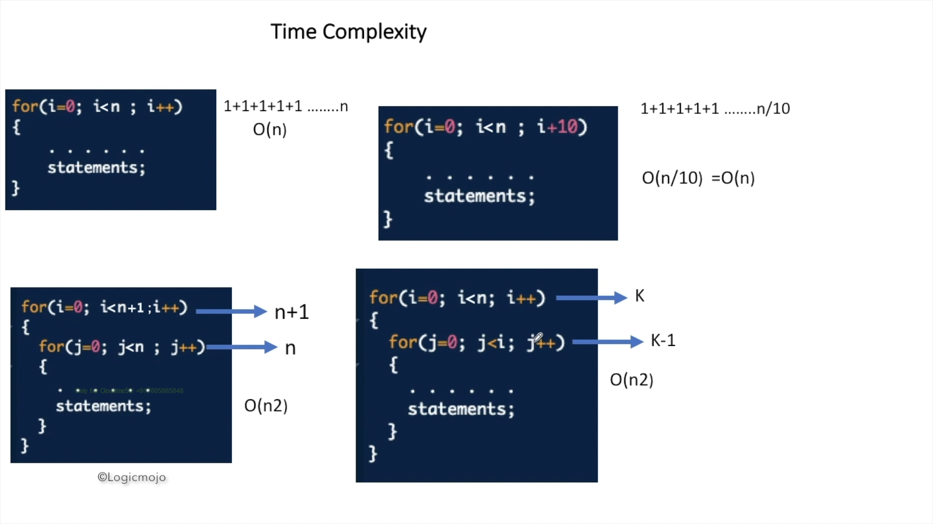

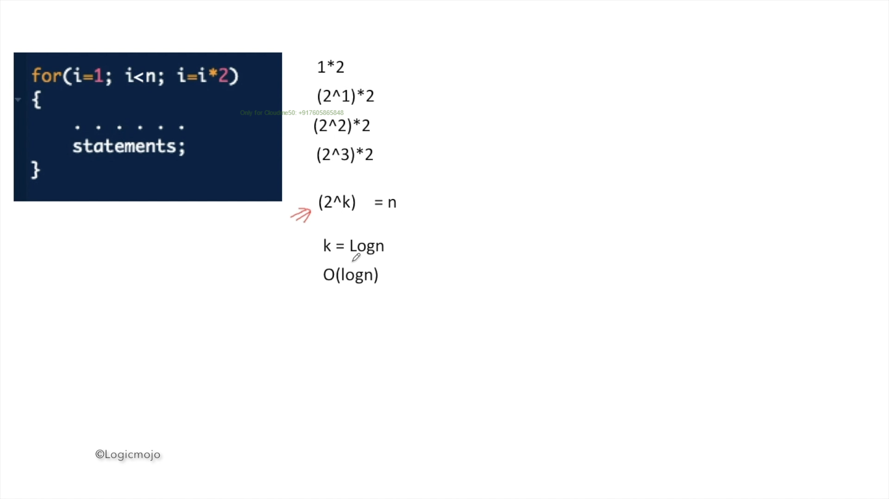

## **2.2 Space Complexity**

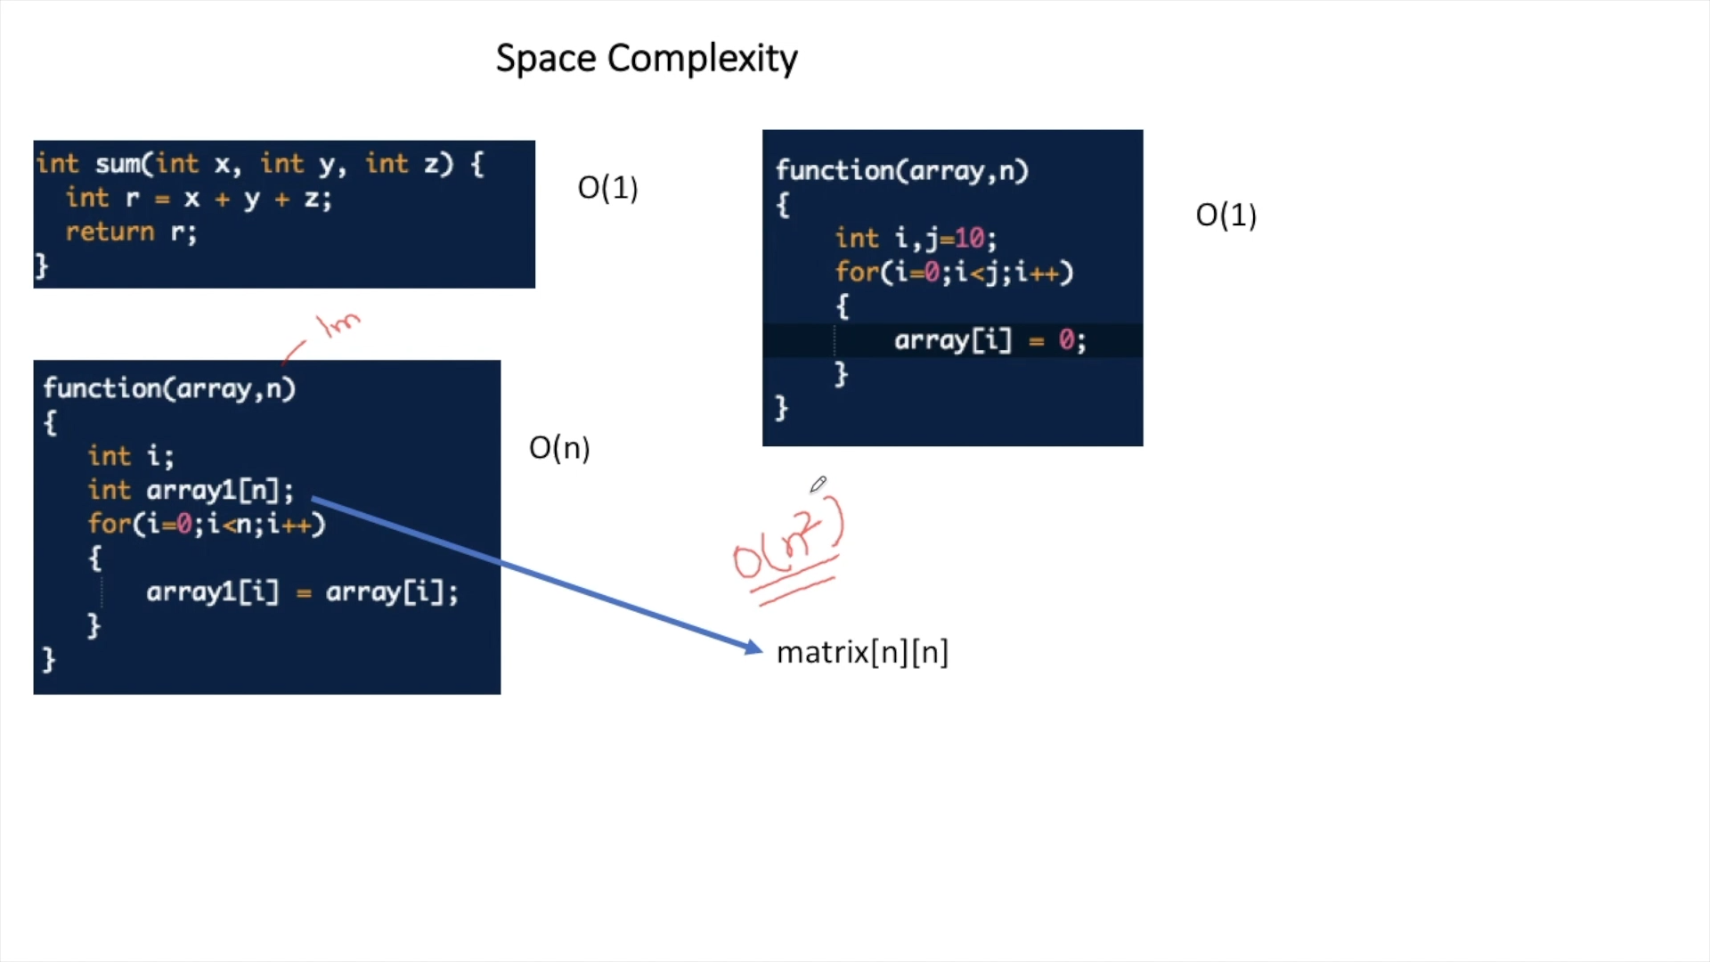

# Search and Sorting

* Mostly Merge sort used 97 % following by Heap sort and Counting sort
* Binary search has O(logN) time

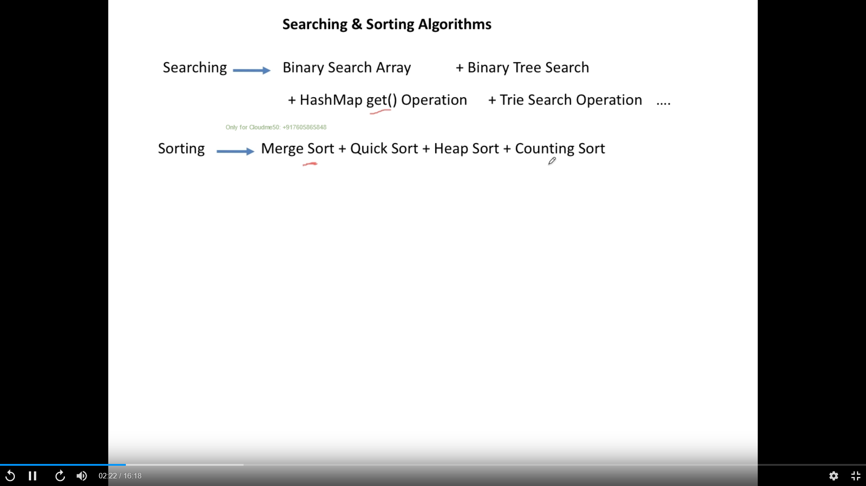

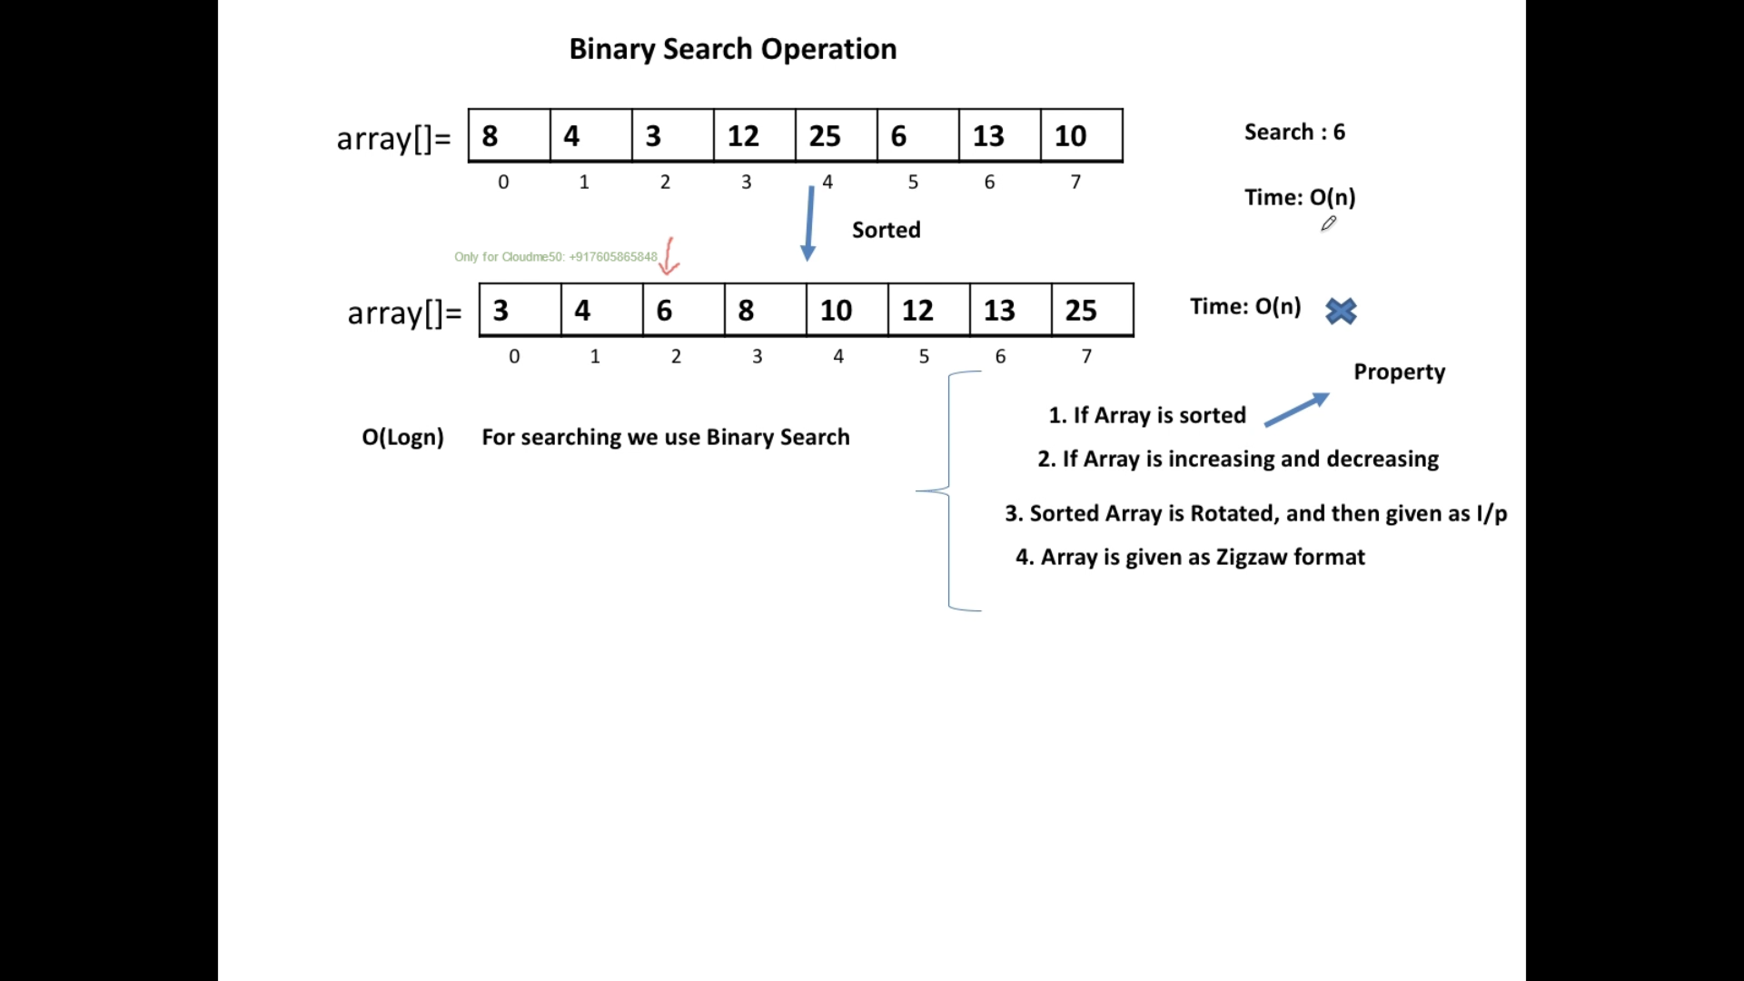

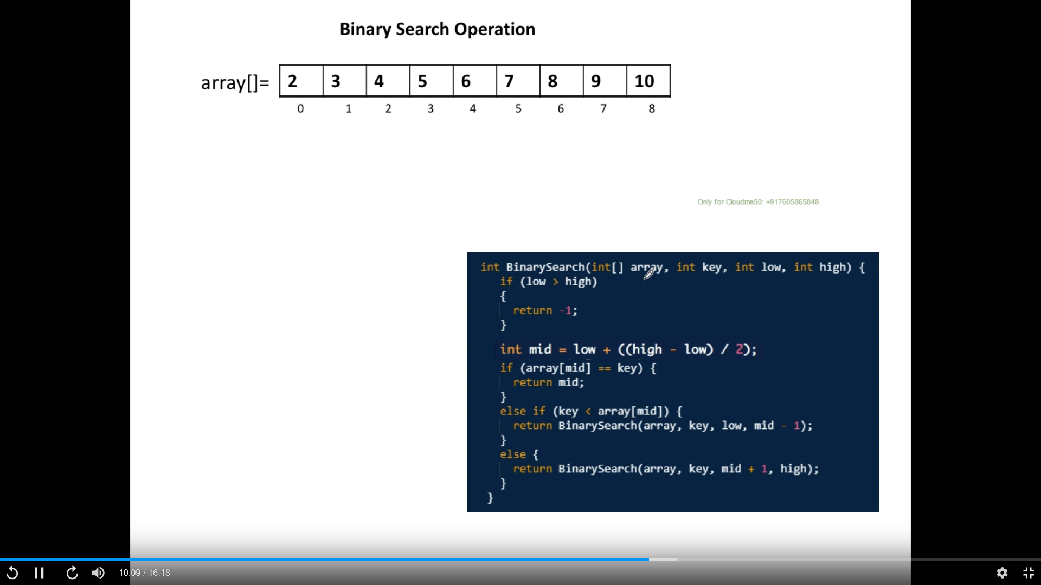

## Sorting Algorithm –

* merge sort used 98 %
  + Divide and concur approach
    - Keep diving an array until it has only one element
* 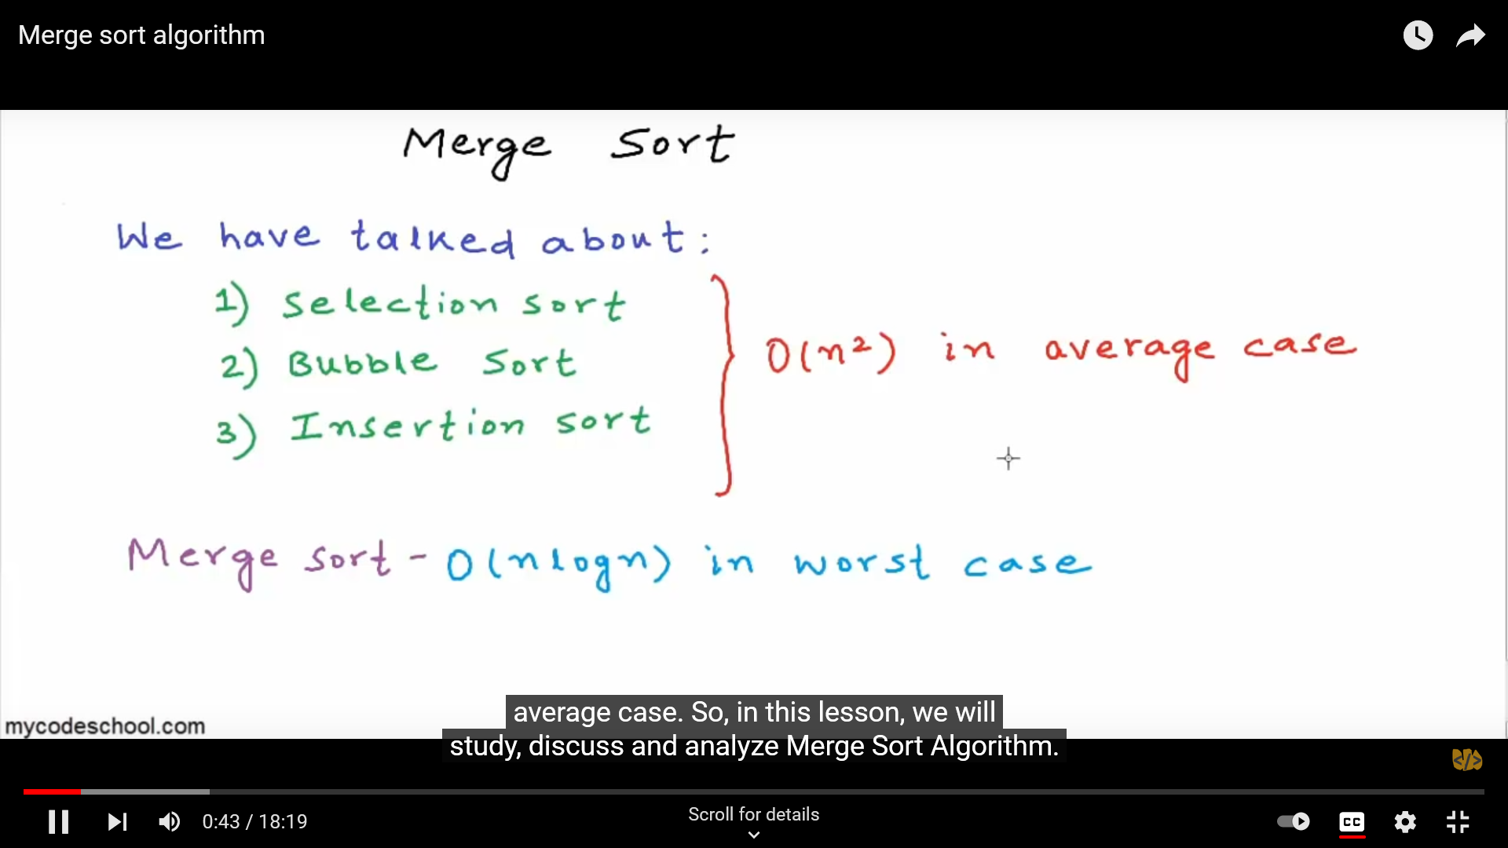

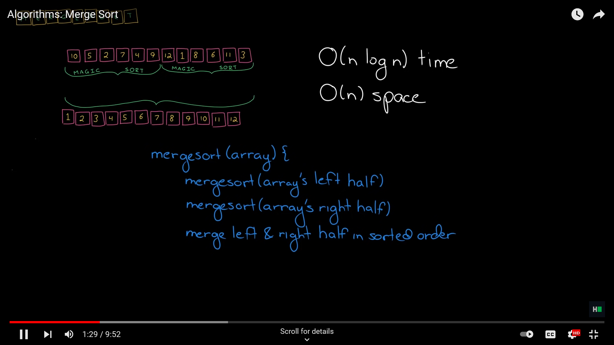

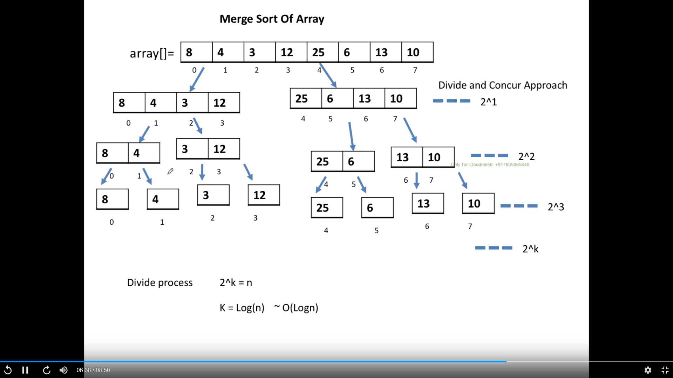

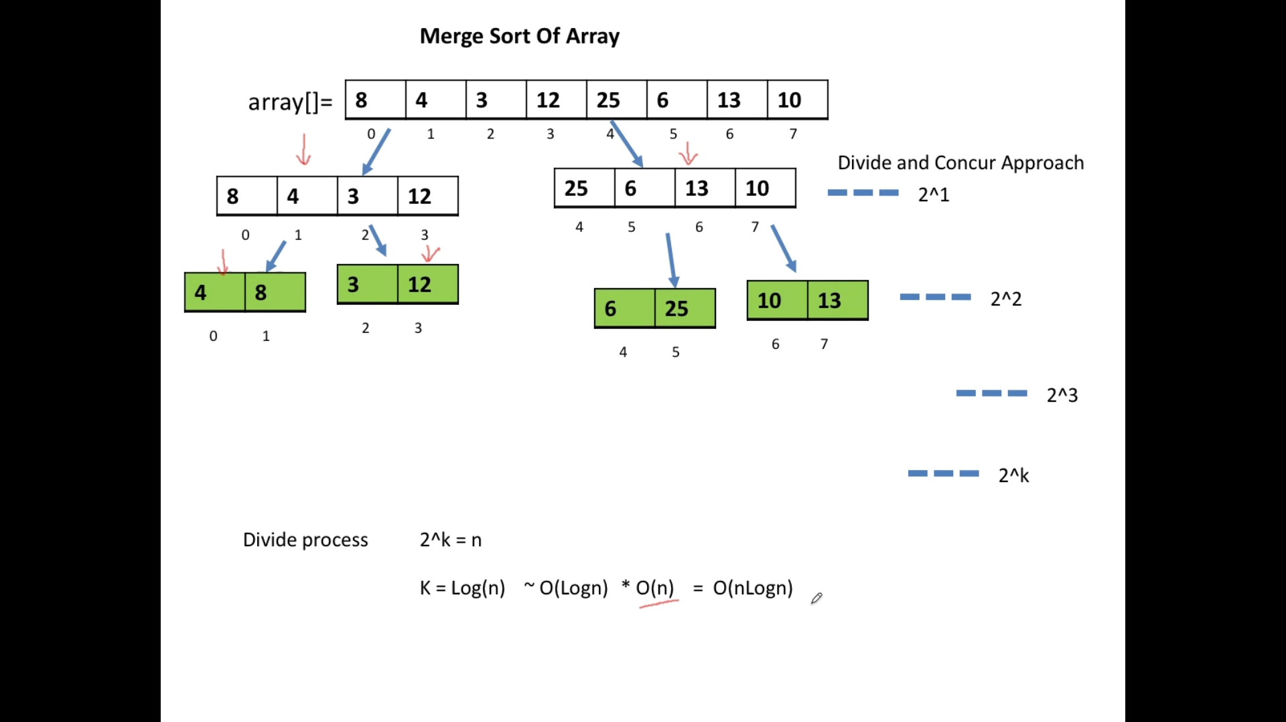

## Merge Sort solution from youtube

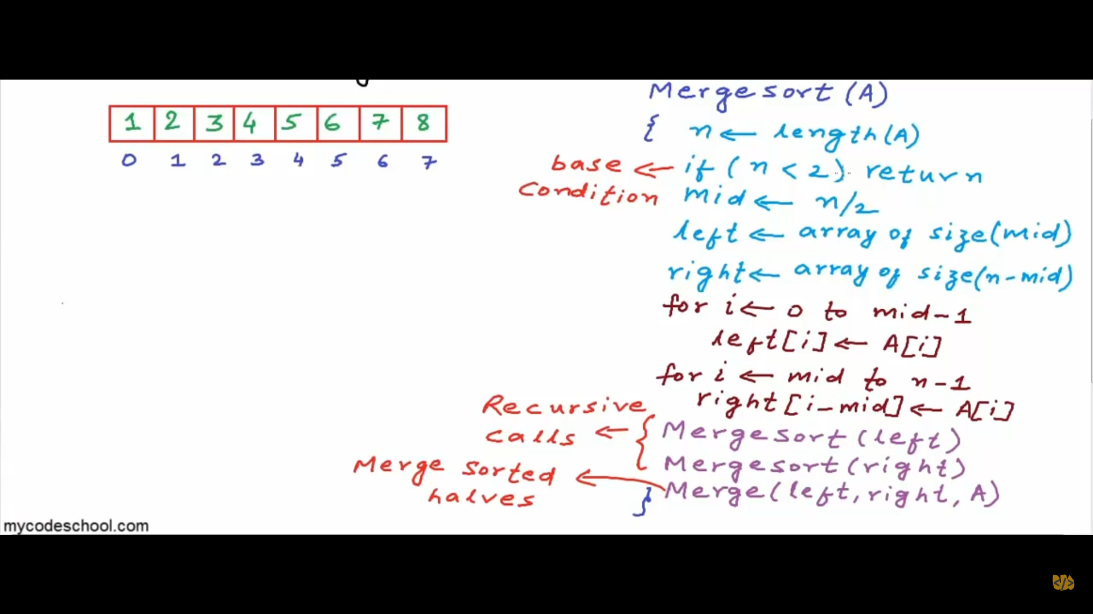

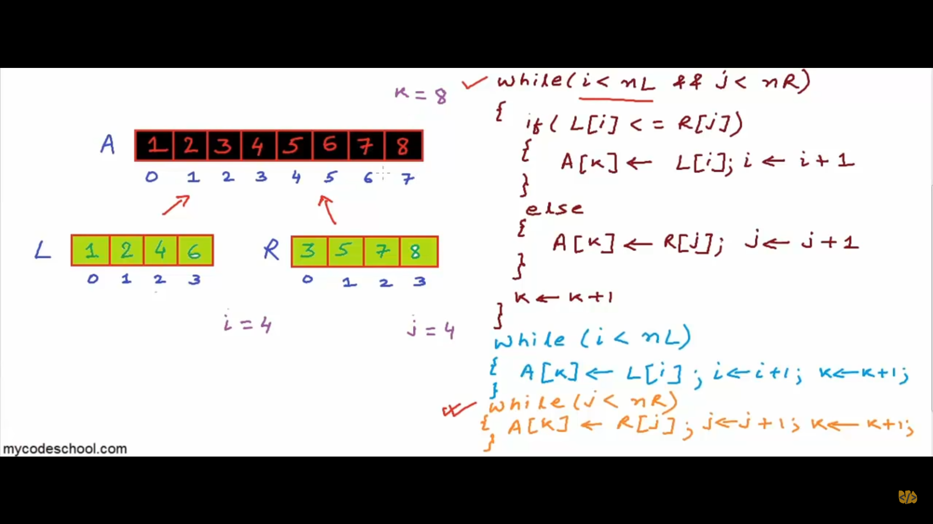

# Recursion

* **Main important** is that call get piled up as stack – LIFO – start executing from first
* Permutation of string
* Knight walk problem in backtracking

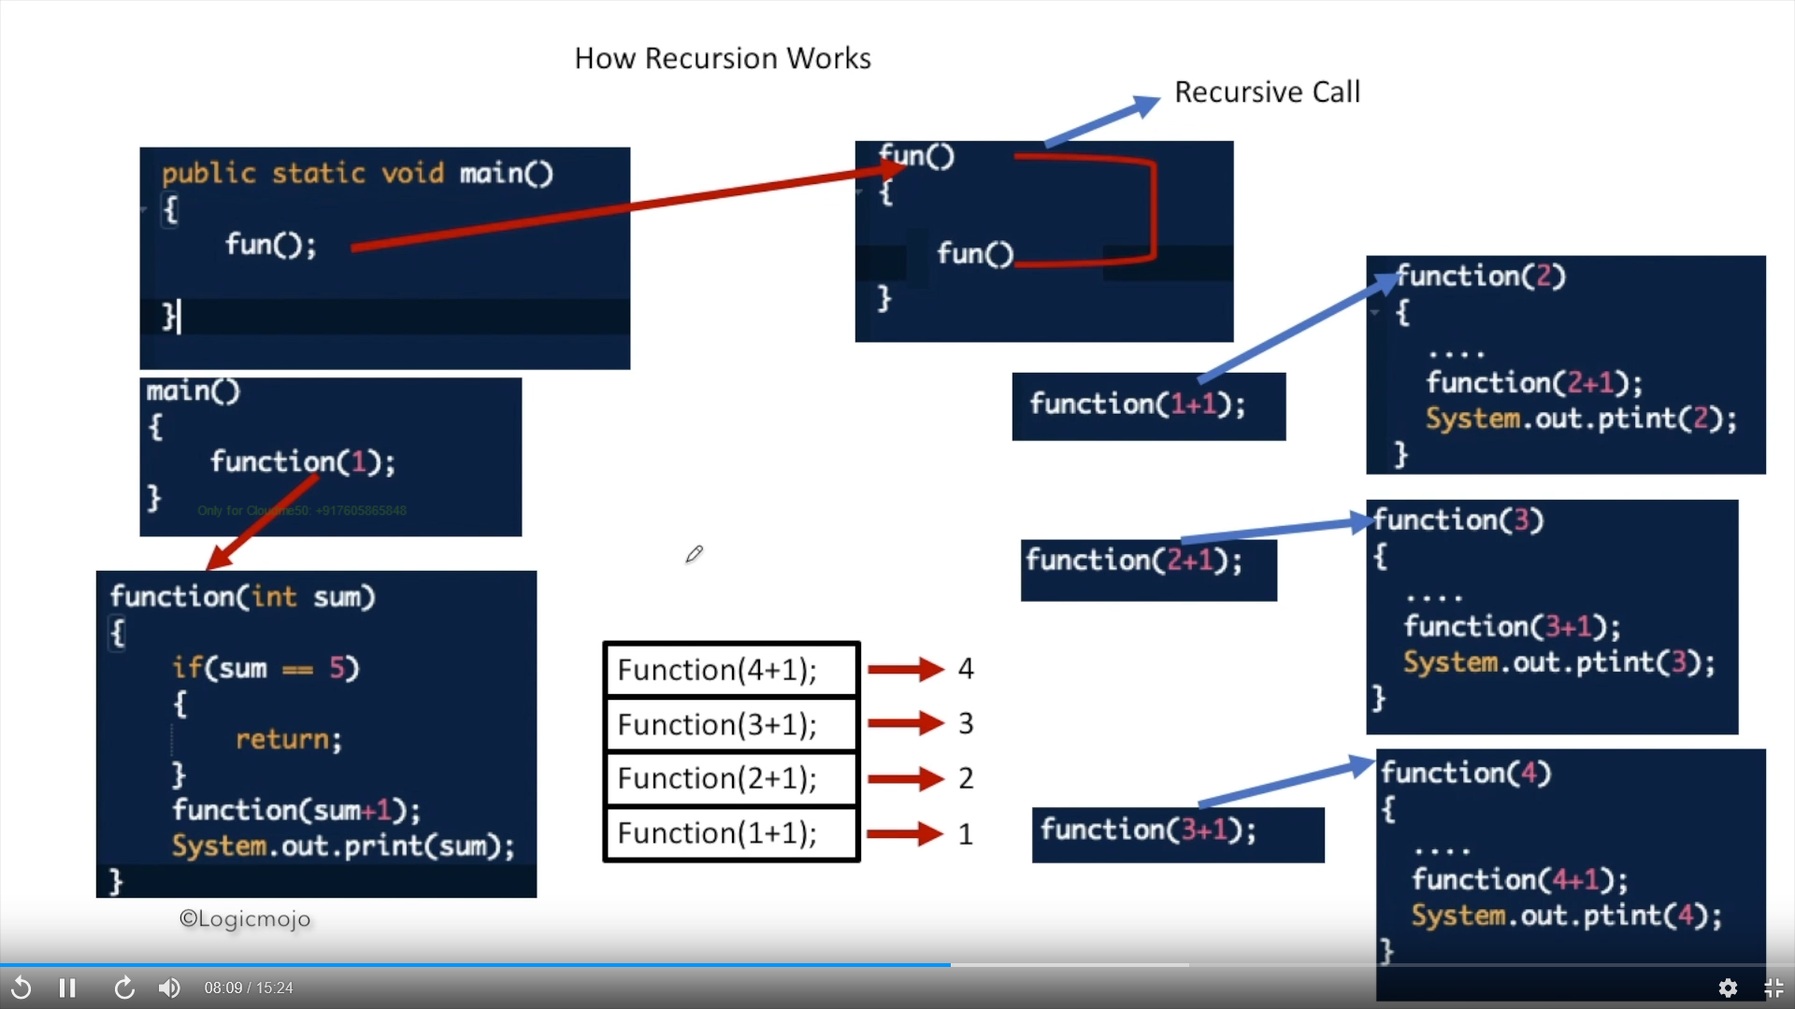

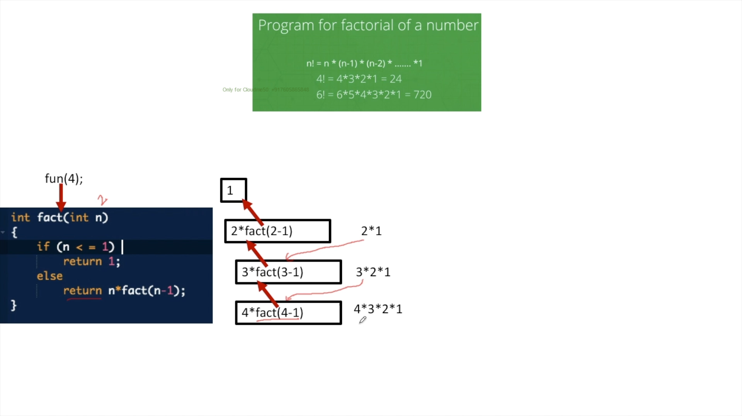

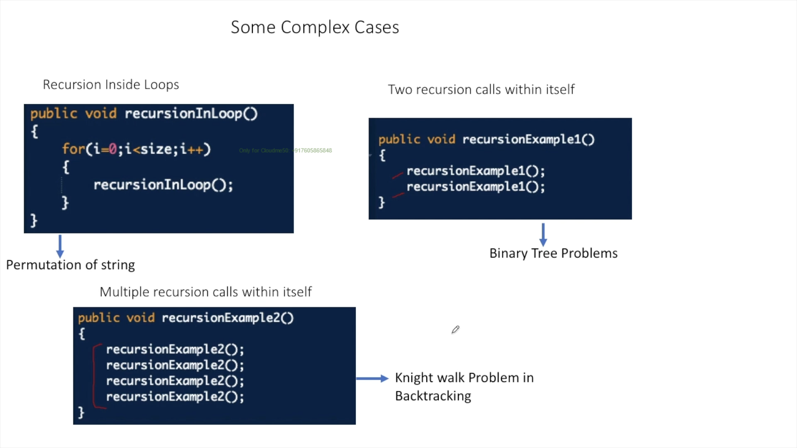

# Binary Tree

## Lab-1

### Create a Node class

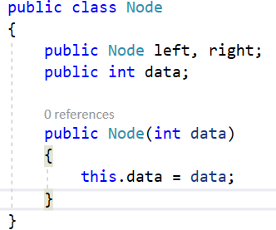

### Create a Binary Tree Parent node

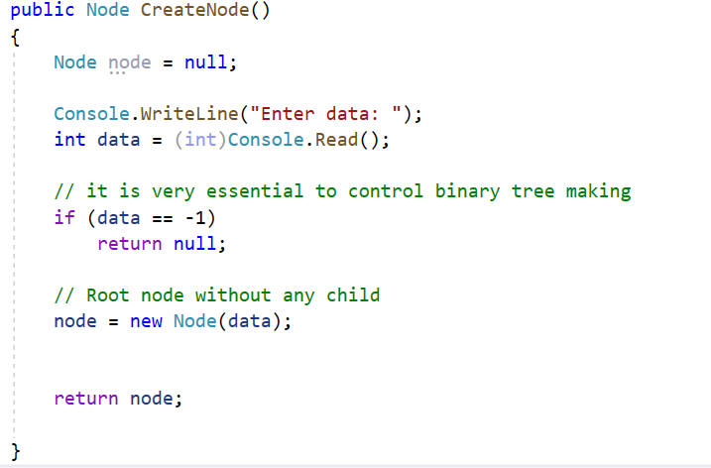

### Create Binary tree left and right node

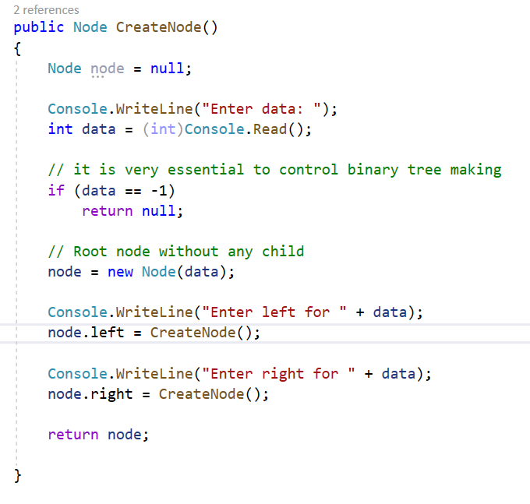

### Traverse the binary tree

* + In order – **LNR**

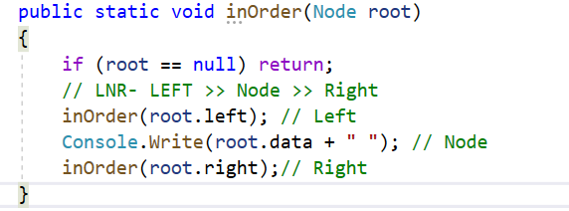

* + Pre- order – **NLR**

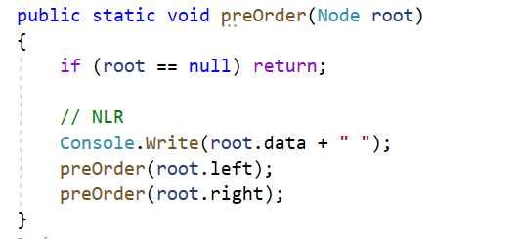

* + Post Order LRN

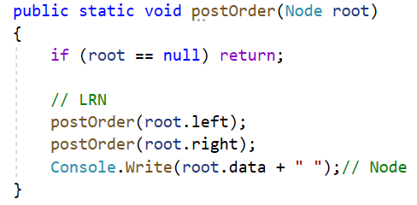

### Call tree and invoke it

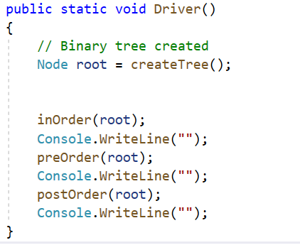

* Final

